Appendix B: Bamlanivimab Infusion Checklist

Purpose: DPH has developed this guide and checklist for Long-Term Care facilities seeking to utilize treatment for residents with mild-to-moderate COVID-19 via provision of Bamlanivimab monoclonal antibody which is under Emergency Use Authorization (EUA) from the Food and Drug Administration (FDA). Such facilities should reference the Guidance for Allocation of COVID-19 Monoclonal Antibody Therapeutics in Non-Hospital Settings as set forth by DPH.

For more information, including provider fact sheets, reference Eli Lilly: Bamlanivimab for COVID-19 (www.lilly.com/news/media/media-kits/bamlanivimab-covid19) and the FDA EUA for Bamlanivimab (https://www.fda.gov/media/143603/download).

This checklist serves as a logistical guide and safety checklist for facilities providing Bamlanivimab to their patients.

Self-Assessment Prior to Engagement:

- Facilities should assess if they have the in-house capacity or a treatment partner who can facilitate infusion of monoclonal antibody treatment for their residents.

- Facilities should determine if they have the means to safely and reliably store the infusion therapy at their location at 2 to 8 degrees Celsius. Unopened vials should remain at this temperature in their original carton to protect from light. They should not be frozen, shaken, or exposed to direct light.

- Facilities should look over the supplies and safety medications noted further below and determine if they have these medications reliably on-hand or if their treatment partner will be able to have them reliably on hand prior to any planned provision of infusion therapy. Facilities should use an IV pump to deliver the infusion medication, not an IV drip.

- Facilities should determine their ability to fulfill supervision needs during infusion. Facilities must be able to recognize severe infusion reactions such as anaphylaxis and have immediate access to treat these conditions with immediately available medication and signal for involvement of higher levels of care. This includes staff who are immediately available to supervise infusion and supervise patients after infusion. Every 30 minute vitals signs should be taken for the hour of infusion and the hour after infusion has finished. A licensed independent provider or nurse may supervise multiple people at once in a treatment/observation room and should be immediately available at all times. Staff should be able to deliver rescue medications as specified.

- In the event of a medication error or serious adverse event, facilities must submit a report on all medication errors and all serious adverse events potentially related to Bamlanivimab per Sections 8 and 9 of the FDA EUA. Such a report can be completed online at: www.fda.gov/medwatch/report.htm

- If the infusions are delivered outside of the resident’s room, in a treatment or observation room, then the room should be located within the COVID-19 space in the facility.

- If the facility can fulfill these items, the facility should arrange to request supply from DPH via OPEM 213TS Resource Request Form found in Appendix A and submit the request to COVID19.Resource.Request@mass.gov.

Patient Selection Assessment:

- Eligible patients include
  - Those ≥ 65 year of age;
  - Those ≥ 55 year of age and have cardiovascular disease or hypertension or chronic obstructive pulmonary disease or other chronic respiratory disease;
  - Those 12 – 17 year of age and have BMI ≥85th percentile for their age and gender based on CDC growth charts, or sickle cell disease, or congenital or acquired heart disease, or neurodevelopmental disorders, or a medical-related technological dependence such as a tracheostomy, gastrostomy, or positive pressure ventilation (not related to COVID-19), or asthma, reactive airway, or other chronic respiratory disease that requires daily medication for control.

- Prioritize those age ≥ 65 and those age ≥ 18 with BMI ≥ 35 (Tier 1) over others who meet EUA criteria (Tier 2). Those at higher risk of progression to severe COVID-19 should also be next prioritized.

- EUA criteria specify that infusions be administered as soon as possible after positive COVID-19 test result and within 10 days of symptom onset (preferably in the first 3 days). A positive COVID-19 (PCR or BinaxNOW) is required for eligibility for this treatment. Symptom onset is required for eligibility for this treatment.

- Bamlanivimab is not authorized for use in patient who are hospitalized, requiring oxygen therapy due to COVID-19 (pulse ox ≤ 93% on room air), or those on chronic oxygen who require an increase in baseline oxygen rate due to COVID-19.

- Patients who have been vaccinated against COVID-19 can receive Bamlanivimab. However if a patient has been treated with Bamlanivimab, current guidance recommends not vaccinating them against COVID-19 until they are 90 days from their onset of symptoms or date of COVID-19 diagnosis.

- Patients with known hypersensitivity to any ingredient of Bamlanivimab must not receive Bamlanivimab.

- Patients or parents/caregivers should be communicated with about risks, benefits, alternatives, and the EUA-nature of the medication and provided with the Fact Sheet for Patients, Parents and Caregivers located at: https://www.fda.gov/media/143604/download. This communication and the consent to receive treatment should be documented in the patient’s medical record.

Infusion Logistics:

- A single 700mg dose of Bamlanivimab is to be delivered over at least 60 minutes via pump (not IV drip to gravity). Bamlanivimab is available as a concentrated solution and requires dilution prior to administration.

- Necessary supplies for infusion include IV pump, IV start kit with tubing and filters, IV catheters, infusion bag of 250mL 0.9% Sodium Chloride, normal saline flushes, alcohol swabs, and severe infusion reaction/anaphylaxis rescue medications as noted further below.

- Remove one Balmanivimab vial (700mg/20mL) from refrigerated storage and allow to equilibrate to room temperature for approximate 20 minutes before preparation. Do not expose the vial to direct heat and do not shake the vial. Inspect the vial for particular matter and discoloration – the vial medication is clear to opalescent, and is colorless to slightly yellow or brown in solution.

- After equilibration, withdraw 20mL of Bamlanivimab from one single vial and inject into an infusion bag containing 0.9% Sodium Chloride Injection. Discard any product remaining in the vial. Gently invert IV bag by hand approximately 10 times to mix. Do not shake. The produce is preservative-free and should be administered immediately. If immediate administration is not possible, store the diluted bamlanivimab infusion solution for up to 24 hours at refrigerated temperature (2°C to 8°C [36°F to 46°F]) and up to 7 hours at room temperature (20°C to 25°C [68°F to 77°F]) including infusion time. If refrigerated, allow the infusion solution to equilibrate to room temperature for approximately 20 minutes prior to administration.

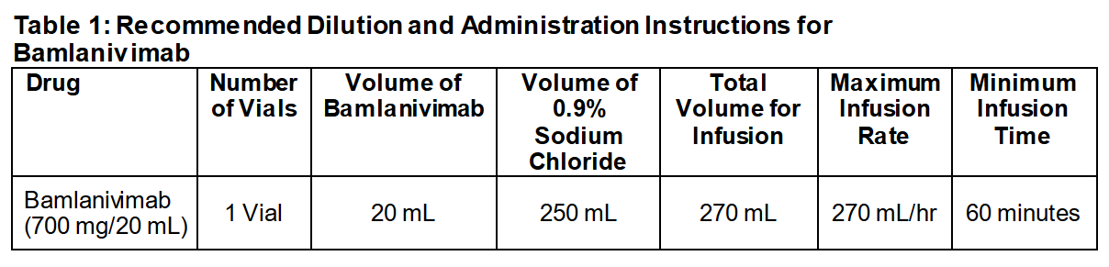

- Bamlanivimab infusion should be administered by a nurse or other licensed independent provider. A polyvinyl chloride (PVC) or polyethylene (PE)-lined PVC infusion set should be utilized with use of an in-line or add-on 0.20/0.22 micron polyethersulfone (PES) filter. The infusion set should be attached to the IV bag, the infusion set primed, and the entire infusion administered via pump over at least 60 minutes. Once infusion is complete, flush infusion line with 10 mL of NS to ensure delivery of required dose

- Patient should be monitored during administration and for at least 1 hour after infusion is complete.

- Infusion-related reactions have been observed with administration of Bamlanivimab. Signs and symptoms of infusion related reactions may include: fever, chills, nausea, headache, bronchospasm, hypotension, angioedema, throat irritation, rash including urticaria, pruritus, myalgia, dizziness. If an infusion-related reaction occurs, consider slowing or stopping the infusion and administering appropriate medications and supportive care. Any unused product should be discarded.

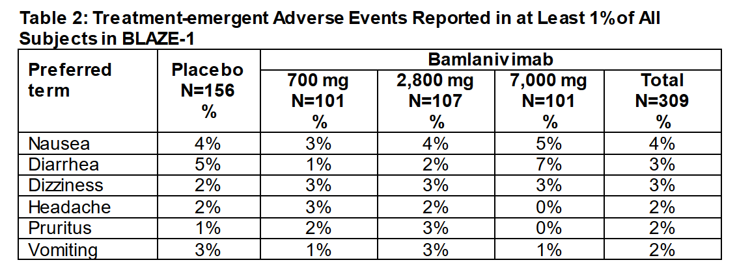

- If signs and symptoms of a clinically significant hypersensitivity reaction or anaphylaxis occur, immediately discontinue administration and initiate appropriate medications and supportive therapy and contact higher levels of medical guidance. Significant hypersensitivity reactions include significant degrees of the infusion-related reactions above, or combinations of multiple symptoms, or unremitting occurrences of those symptoms. Anaphylaxis recognition requires clinical judgment and can include respiratory compromise such as wheezing, stridor, hypoxemia; reduced blood pressure; syncope; collapse; incontinence; persistent mucosal involvement such as hives, itching, angioedema; and persistent GI symptoms such as cramping abdominal pain and vomiting.

- Treatment of anaphylaxis and significant hypersensitivity reactions includes Epinephrine 1mg/ml amp (1:1000) delivered as 0.3mg intramuscular and able to repeated as needed every 3 to 5 minutes, Diphenhydramine 50mg/mL vial delivered as 50mg via slow intravenous or intramuscular injection, Methylprednisolone delivered as 125mg intramuscularly, and Albuterol inhaler delivered as 90mcg/puff 1-2 puffs as needed. Sites are additionally encouraged to keep on hand oxygen, pulse oximeters, H2 anti-histamines such as Famotidine, and appropriate resuscitation materials inclusive of one-way CPR valves. Treatment and supportive care should be initiated and higher levels of care should be summoned for ongoing patient management.
Post Infusion Care:

- Patients treated with Bamlanivimab, after treatment, should continue to self-isolate and use infection control measures (e.g., wear facemask, isolate, social distance, avoid sharing personal items, clean and disinfect “high touch” surfaces, and frequent handwashing) according to CDC guidelines.

❑ Those at higher risk of progression to severe COVID-19 include those with BMI ≥ 35, chronic kidney disease, diabetes, immunosuppressive disease, currently on immunosuppressive treatment, cardiovascular disease, hypertension, chronic obstructive pulmonary disease, other chronic respiratory disease, sickle cell disease, congenital or acquired heart disease, neurodevelopmental disorders, medical related technological dependence such as tracheostomy, asthma, reactive airway disease, or other chronic respiratory disease.

