SAMPLE RESOURCE

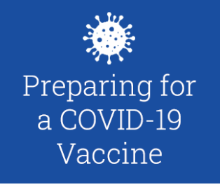

**Chelsea Soldiers’ Home**

**COVID Vaccine Clinic Implementation Guide**

Contents

**Soldiers’ Home COVID-19 vaccine planning workstreams** 4

CVS Timeline 4

CVS Clinic Model 5

**A Safe Vaccine Clinic Environment** 5

Infection Control 5

Security 6

Quigley Building Long Term Care COVID Clinic 6

Domiciliary Clinic 7

**Roles and Duties** 7

Vaccinator 9

Observer 9

Credentialed Staff 9

Designated Clinical Area 9

Residents (LTC/SNF) Rooms 10

On-Site Vaccine Clinic Manager 10

Start of Clinic Day: 10

End of Clinic Day: (Homes) 10

**Clinic Schedule & Staffing** 10

Clinic Schedule 10

Staffing 10

**Training Materials & Clinic Supplies** 10

Training Materials: 10

Clinic Supplies: (Homes to provide) 11

**Documentation Needs** 12

Documentation 12

IS Hardware\Internet Access Needs 12

**Vaccine Refrigeration and Storage, Inventory Control and Pharmacy Workflow, Pfizer and Other Vaccine Product Information - CVS Responsibility (note this is not the Home’s responsibility)** 12

Refrigeration & Storage 12

Inventory Control & Pharmacy 12

More about the Pfizer Vaccine 12

**Key Contacts** 13

**Frequently Asked Questions** 13

Appendix I: Checklist 15

Expected Vaccine Clinic Date: 15

Instructions: 15

# **Soldiers’ Home COVID-19 vaccine planning workstreams**

Communications

## CVS Timeline

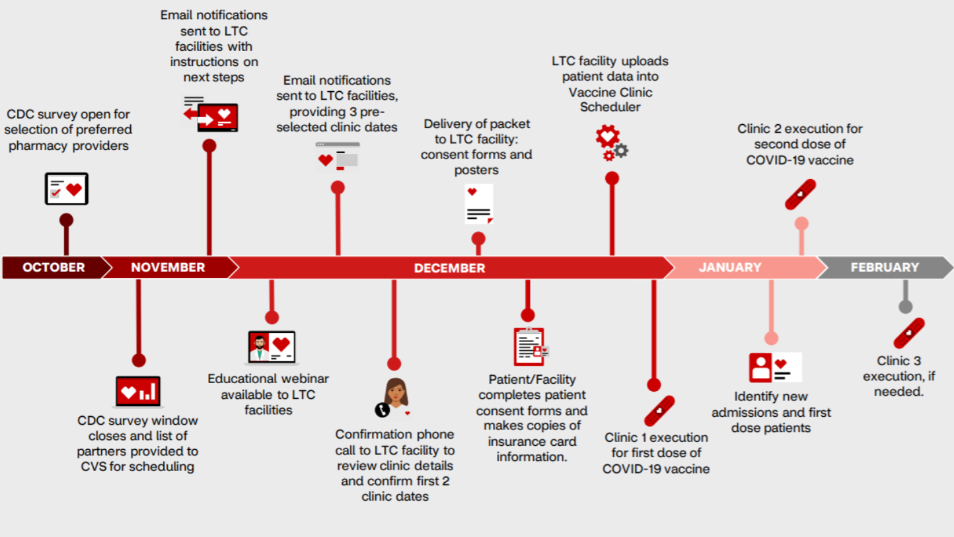

## CVS Clinic Model

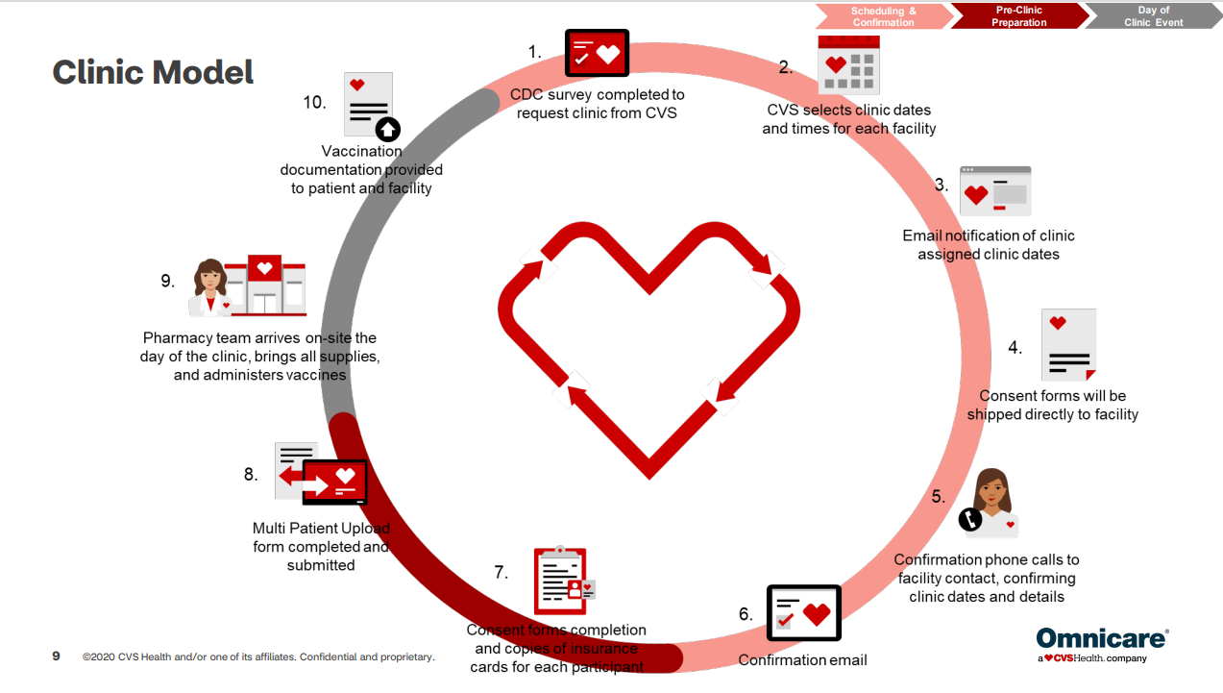

# **A Safe Vaccine Clinic Environment**

* Hosted on campus

## Infection Control

* Infection Prevention and Control (IPC) staff is knowledgeable about the selected vaccination site and has reviewed the Playbook.
* All staff must be knowledgeable regarding relevant infection control policies.
* Vaccine administration stations and observation seats are 6 feet apart, and each station and observation area have dedicated and full hand hygiene dispensers and required PPE, readily replenished.
* Vaccine administration stations and high touch surfaces in observation areas are cleaned and disinfected at minimum every hour per [CDC recommendations](https://www.cdc.gov/vaccines/hcp/admin/mass-clinic-activities/during-clinic-activities.html), between shifts and at the end of the clinic day, and if visibly soiled. Cleaning and disinfection is performed by the vaccinator or room assistant, or other role designated by the local institution. Please note it may be more reliable to perform cleaning and disinfection of the stations between each employee to ensure this is performed at a minimum once per hour. Alternatively, the clinic may choose to establish a set cleaning and disinfection time at the same time each hour, and ensure sufficient time for cleaning and disinfection, considering product contact time.[1]
* Staff must adhere to social distancing while waiting.
* Masks and hand hygiene stations are available at entry/check-in and replenished; all employees arriving for vaccination will wear appropriate PPE
* No eating or drinking in vaccination area unless part of emergency response
* Personal Protective Equipment for vaccine clinic staff
  + All vaccine clinic staff adhere to facility personal protective equipment requirements
* Frequently touched objects and surfaces such as doorknobs are cleaned and disinfected every hour (please see above on surfaces and timing1).
* Frequently clean and disinfect all patient service counters and patient contact areas, including frequently touched objects and surfaces such as workstations, keyboards, telephones, and doorknobs. Ensure wipes are wet, but not dripping to avoid damaging the device (e.g., too much disinfectant could seep into the ports).
* All clinic and vaccination area are cleaned at end of day by Environmental Services

## Security

* Badge access granted to all necessary staff, including: Pharmacy, Vaccinators, Observers, Clinic Operations & Administration.
* Campus police should be aware of security needs. Each site will need to include their local Security team in their operational staffing plans
* Ensure site-based Security/Administration staff knows the clinic’s location and hours of operation, including the time for set up and break down of the clinic.
  + During check-in, employee provides proof of ID with either employee badge or license. Employee verifies date of birth.
  + Identify other security concerns need to be addressed at identified clinic sites.

## Quigley Building Long Term Care COVID Clinic

* Location is the Recreational Room on the 1st floor of the Quigley building.

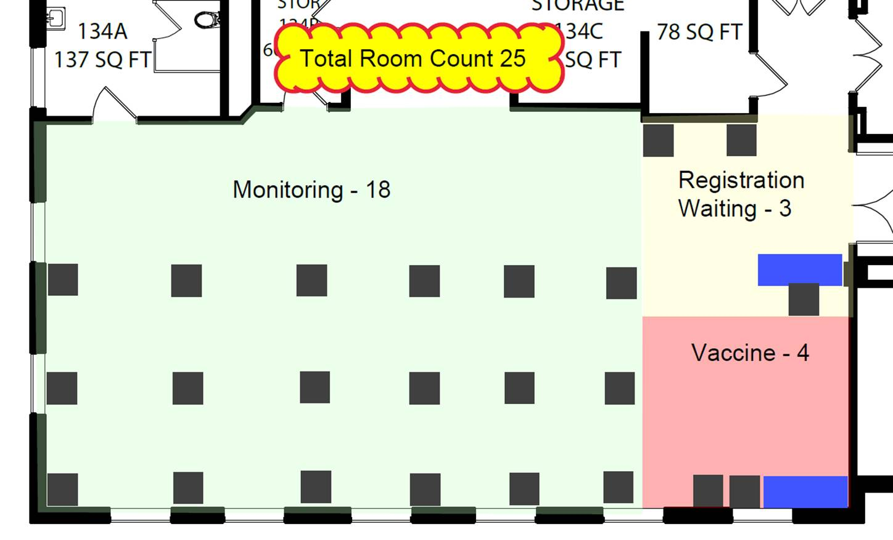

## Domiciliary Clinic

* Location is the DCCU located on the ground floor of the John Adams building.

# **Roles and Duties**

|  |  |  |
| --- | --- | --- |
| **Role** | **Name** | **Function** |
| Superintendent | [insert staffing specialist] | Oversight of all vaccine operations |
| Senior Operations Manager | [insert staffing specialist] | Supports Superintendent in overseeing all vaccine operations, including Pharmacy |
| Chief Pharmacy Officer (CVS) | [insert staffing specialist] | Provides vaccination |
| Medical Director | [insert staffing specialist] | Clinical oversight |
| Chief Nursing Officer | [insert staffing specialist] | Clinical oversight |
| Infection Control Nurse | [insert staffing specialist] | Ensure all infection control protocols are followed |
| Clinic Supervisor(s) | [insert staffing specialist] | Onsite Home clinician responsible for communicating updates to chain of command |

|  |  |  |
| --- | --- | --- |
| **Role** | **Duties** | **Area** |
| **On-Site Vaccine Clinic Manager** | * CVS | Established clinic area (see map above) |
| **Greeter/Check-In:** (CVS & Homes) | * TBD <insert names> * Asks individual to use hand disinfectant and check that mask use is correct. * Confirms that all employees entering vaccine area do not have symptoms. * Checks-in individuals (ensures they have appointment) (develop talking points) * Verifies that individual can remain on site following vaccination for 15 to 30 minutes for observation. If unable, reschedule vaccination. * Directs individual to a vaccination station using the # on the station as a reference. * Directs individual to the next available vaccination station. Consider the vaccine preparation to be provided as individual may need to be directed to a specific vaccination station. * Answers questions and manage traffic flow. * Notifies on-site Vaccine Clinic Manager if an individual has a question the Greeter cannot answer. | Check-in at clinic entrance after going through screening process to enter the building |
| **Room Assistant/Table Wiper**: (Infection Control) | <Homes to identify resources>:   * Clean and disinfect each vaccination station table between employees with a hospital approved wipe or at the scheduled hourly cleaning time. Use enough wipes to ensure surfaces are wet for appropriate contact time and allow to air dry. | Established clinic area (see map above) |
| **Vaccinator (CVS Role)** | * See detailed checklist of responsibilities below | [Insert location of vaccination stations] |
| **Observer (Home’s Role)** | * See detailed checklist of responsibilities below * Must be trained in emergency response | [insert identified observation area] |
| **Staff Scheduler (CVS Role) & Home’s scheduler** | * Schedules appropriate clinic staff with appropriate staffing mix (CVS Vaccinators & Home’s Observers) * Schedules clinic staff 30 min before clinic opens 1st week * Works with Leadership to identify staffing gaps (Homes) * Communicates staff issues to Manager Any staff issues (e.g., no shows, substantially late for shift) (Homes) | [insert staffing specialist] |
| **Appointment scheduler/check-out staff (CVS Role)** | * We will not be using the Vaccine Clinic Scheduler (CVS technology) – for appointments * Vaccination prioritization will be residents first, front-line direct care staff, followed by support staff, and then executive leadership. | Vaccination prioritization will be residents first, front-line direct care staff, followed by support staff, and then executive leadership. |

## Vaccinator

* The Soldiers’ Homes have enrolled in the CDC’s Long-Term Care Pharmacy Partnership program to offer COVID-19 vaccination services. You can read more about this program [here](https://www.cdc.gov/vaccines/covid-19/long-term-care/pharmacy-partnerships.html). However, the CVS is currently only providing three site visits and vaccinators will be needed after the CVS program expires.
* Clinical roles that can be vaccinators:
  + LPNs, RNs, NPs, MDs, PA’s
  + Pharmacists and pharmacist interns
* Screens for contraindications
* Reviews the information sheet and determines if the individual has any concerns or questions
* Advises regarding observation process following vaccination
* Provided FAQs and resource link to FAQs EUA
* Vaccination Process
  + Determine which arm will receive the vaccine based on individual’s dominant hand, contraindications to injection in an arm (e.g. mastectomy with lymphedema), and individual’s preference
  + Have the individual roll up their sleeve to the top of their arm.  If unable to do so, can unbutton the top of the shirt and pull it down from the collar. If unable to get to the upper arm, have the individual partially disrobe with privacy.
  + Choose correct needle size based on patient size.
  + Use a separate needle and syringe for each injection.
  + Only administer vaccines clinical provider has provided. This is a medication administration best practice standard. If vaccine is drawn up by one person but administered by another, the person administering the vaccine cannot be sure what is in the syringe and whether it is safe.
  + Perform hand hygiene, don gloves, inject vaccine intramuscularly into the individual’s arm
  + Document the vaccination.
  + Document the vaccination on the card provided by MDPH and give to the individual. Provide the following to the individual: employee handout on post vaccination, EUA required handout, and applicable handouts.
  + Direct individual to observation area.

## Observer

### Credentialed Staff

* Required credentials/skillset: LPN (with core competencies), NP, MD or RN.

### Designated Clinical Area

* Observes individual(s) per EUA (15 minutes to 30 minutes) following their vaccine administration.
* Maintain 1 observer in the observation area with view of all vaccinated.
* Ensure Observer has documented procedure for contacting emergency response.
* Room Assistants make sure common tables and chairs are wiped down between individuals and at end of clinic day

### Residents (LTC/SNF) Rooms

* Observes residents per EUA (15 minutes to 30 minutes) following their vaccine administration.
* Assign appropriate number of Observers based on number of residents vaccinated.
* Ensure Observer has documented procedure for contacting emergency response.
* Care Plans will be updated regarding additional observations needs for residents.

## On-Site Vaccine Clinic Manager

### Start of Clinic Day:

* CVS is the clinical manager for inoculation (three site visits)
* Homes’ Reasonability:
  + Ensures adequate carts with supplies to go unit to unit based on number of vaccinators being provided by vendor.
  + Campus Police or designated point of contact to escort CVS staff to clinic location.
  + Ensure WIFI password and power is provided.
  + Provide

### End of Clinic Day: (Homes)

* + Straighten up vaccination stations and reception station
  + Ensure all areas are cleaned and disinfected; ensure Environmental Services arrives for end of day cleaning
  + Take inventory & replenish supplies
  + Order/coordinate supply needs for replenishment
  + Ensure workstations are wiped down, shutdown and plug into charge
  + Send end-of-shift summary email to site Ops Leader with requested information (e.g. # of staff vaccinated, call out info, etc.)

# **Clinic Schedule & Staffing**

## Clinic Schedule

* Define hours of operation:
  + Hours are 11AM – 5PM

## Staffing

* + Assign clinic Staffing Specialist(s)
  + Establish procedure for clinic staff to call in if not able to make scheduled shift
    - * Clinical Supervisor to provide updates to chain of command and resource/supply needs.

# **Training Materials & Clinic Supplies**

Training Materials:

Training materials to be provided along with supportive documents from CDC/DPH:

* CVS provided COVID vaccination training
* CDC vaccination training
* Soldiers’ Home Infection Control policies
* Universal Mask Policy, Universal Eye Protection Policy, Extended Use, Reuse, and Conservation of PPE Policy
* Vaccination Technique
* Key pre-vaccination counseling including Contraindications
* Key post-vaccination counseling
  + scheduling second dose
  + how to report adverse event
  + how to report blood/body fluid exposure
* Vaccination clinic workflow
* Training on how to obtain emergency assistance (with emergency kit)

## Clinic Supplies: (Homes to provide)

* Nitrile gloves: small 25%, medium 50%, large 25% (gloves are not provided in the Pfizer kit)
* Masks at screening
* Chux/disposable pads
* Paper towels
* 2-3 Emergency kits
  + Epinephrine, autoinjector
  + Diphenhydramine
* Band-aids and gauze pads
* Ice pads
* Blood pressure measuring device
* Pens, paper, tape
* Vaccine station # signs
* 1 station for every vaccinator with 2 chairs (avoid fabric and ensure wipeable arms), wastebasket, sharps containers, hand sanitizer dispenser
* 1 station for check-in/check-out at vaccination clinic entrance
* Enough chairs in observation space, set up 6 feet apart from each other
* Screens to allow for disrobing: 1 per clinic during the winter months
* Hand sanitizer locations
  + entry and exit to clinic and observation space
  + every vaccination station
  + workstations
* Facility approved signage
  + physical distancing markings on floor to stand 6 ft apart
  + “not feeling well signs:” procedures to follow if on site and have symptoms
* Adult size pocket mask in every size for rescue breathing (ambu bag can also be used)
* Appropriate PPE – all types Masks, Gowns, Eye Protection, Gloves
* EPA N-list approved disinfectant wipes to wipe down stations, chairs, laptops
* Information Guidance Sheet on Vaccine – FAQ EUA at this time as no VIS exists
* Access to Interpreter or Interpreter Call Services
* Other clinical items will be provided in the vaccine kits but clinics might consider pulling more on site proactively.

# **Documentation Needs**

## Documentation

All documentation will be performed in accordance with Homes’ policy.

Appointment scheduling:

* + Scheduling will be done via Vaccine Clinic Scheduler (CVS technology)

## 

## IS Hardware\Internet Access Needs

Clinics to be prepared to assist with the following:

* WIFI access for CVS
* Possibility for providing printer capabilities

## **Vaccine Refrigeration and Storage, Inventory Control and Pharmacy Workflow, Pfizer and Other Vaccine Product Information - CVS Responsibility (note this is not the Home’s responsibility)**

### Refrigeration & Storage

It is recommended that refrigerators be provided by local Pharmacy Department provided the clinic is located on-site. Temperature monitoring should be managed with the site’s Pharmacy Supply Chain lead and site operations point of contact. Ifthe site and workflow do not have refrigerator capacity, coolers might be considered as an alternative.

### Inventory Control & Pharmacy

Local Pharmacy Department will deliver vaccine at the start of each clinic’s day and collect unused vaccine at the close of the clinic’s day to ensure inventory control. Each clinic needs to work with their local Pharmacy Department supply chain contact and share the clinic schedule for proper coordination. Clinics should place their next day’s order with their Pharmacy Department contact by *early*afternoon (1:00pm). This should be done by the site’s Ops leaderwho is informed about vaccine availability.

More information on reconciliation process for end of day, and documentation/reporting (MIIS) will follow.

### More about the Pfizer Vaccine

* 5 doses/vial
* Undiluted and/or intact vial must be used within **5 days**
* Manipulated and/or diluted vial must be used within **6 hours**
* Pfizer vaccine kits (supplies to administer 100 doses of vaccine)
* Needles, 105 per kit (various sizes for the population served by the ordering vaccination provider)
* 25 gauge,1”(if vaccination indicated for pediatric population)
* 22-25 gauge,1-1.5”(adult)
* Syringes, 105 per kit (ranging from 1–3 mL)
* Alcohol prep pads, 210 per kit
* 4 surgical masks and 2 face shields for vaccinators per kit
* COVID-19 vaccination record cards for vaccine recipients, 100 per kit
* Vaccine needle guide detailing the appropriate length/gauge for injections based on route, age (for children), gender, and weight (for adults)
* Gloves not included

It is recommended that towards the end of the clinic’s day, the vaccine administration stations share vials of Pfizer product to prevent waste.

*Other Vaccine Product Information*

Once additional product (e.g. Moderna) becomes available this document will be updated to include product specific information and planning. When more than one vaccine product is available, vaccination stations should be product-specific to reduce the likelihood of administration errors. Once additional product is available, clinic refrigerators should have dedicated, clearly labeled shelves by vaccine product.

# **Key Contacts**

Use internal phone or electronic directory to identify the following contacts:

|  |  |  |
| --- | --- | --- |
| **Site** | **OHS Contact for Decisions/Ops** | **Operational Leader** |
| A |  |  |
| B |  |  |
| C |  |  |

# **Frequently Asked Questions**

* Develop permanent employee-facing FAQs for employees. Once available, it is helpful to print a few copies in both English and Spanish, which Intake Staff and Greeters can have available to give to employees.
* Establish email distribution dist of all vaccinators and vaccine clinic administrators for communication of updates.

|  |  |  |
| --- | --- | --- |
| **Department** | **Contact** | **Contact Method** |
| **Buildings & Grounds** | Contact for Clinic Set Up (tables, chairs, power cords, etc.) | Phone:  Email: |
| **Campus Police** | Security Dispatch | Phone: 617-438-8395 |
| **Environmental Services**  (Spill Clean Up, Sharps Containers, Wastebaskets, Daily Cleaning) | House Keeping Supervisor (24/7) | Phone:  Email: |
| House Keeping Supervisor (24/7) | Phone:  Email: |
| **Food Services** | Catering Services | Phone:  Email: |
| Catering Manager | Phone:  Email: |
| **Information Systems (IS)** | Primary:  Brian Chase | Phone:  Email: |
| Secondary: CHE IT | Phone:  Email: |
| **Interpreter Services** | Spanish (24/7) | Phone: TBD |
| American Sign Language (24/7) | Phone: TBD |
| All languages (main campus only) (24/7) | Phone: TBD |
| **Materials Management** (Supplies) | Central Supply | Phone:  Email: |
| **Occupational Health** | OHS Employee | Phone:  Email: |

# Appendix I: Checklist

## Expected Vaccine Clinic Date:

**Clinic to be run by: □ CVS □ Walgreens □ LTC Pharmacy: Primary Facility Coordinator: Name:**

# **Tel:__________________________________________________________________________ Email: ______________________________________________________________________**

**Point of Contact at Pharmacy: Name: Tel: Email:**

## Instructions:

* The primary facility coordinator must work with their assigned point of contact at the pharmacy to personalize this form to their own timeline, facility logistics and specific pharmacy requirements.
* The primary facility coordinator and pharmacy point of contact should agree on timelines up front. Any major changes to the timeline should be communicated to the pharmacy point of contact.

|  |  |  |  |  |
| --- | --- | --- | --- | --- |
|  | **Pre-Vaccine Clinic Day (>10 days)** | **Lead Person** | **Target Date to Complete** | **Notes** |
| □ | Establish facility point of contact to talk with pharmacy and plan clinic:  Name: |  |  |  |
| □ | Contact pharmacy partner |  |  |  |
| □ | Identify facility nurse to assist with the COVID-19 vaccine clinic.  Name: |  |  |  |
| □ | Identify Vaccine Clinic Area for Staff and Residents   * Well-ventilated area * Allow 6-feet physical distancing while people wait (pre- and post- vaccine) * Need source control masks for staff and residents getting vaccinated * Identify residents needing bedside vaccination   Discuss space requirements with pharmacy partner |  |  |  |
| □ | Confirm with pharmacy any supplies needed for vaccine clinic (tables, chairs, etc.). |  |  |  |

|  |  |  |  |  |
| --- | --- | --- | --- | --- |
|  | **Pre-Vaccine Clinic Day (>10 days)** | **Lead Person** | **Target Date to Complete** | **Notes** |
|  | * Insurance information for staff and residents * Primary care physician * Consent forms & calls to responsible parties   Discuss specific information required with your pharmacy point of contact |  |  |  |
| **Establish a process for collecting consent** | | | | |
| □ | Identify who will oversee collection of resident consent:  Name: |  |  |  |
| □ | Obtain copies of   * Pharmacy consent form * Ensure documentation in resident records regarding any verbal or email consents obtained * FDA EUA fact sheet for consent |  |  |  |
| □ | Identify which residents can consent themselves and who needs healthcare proxy to sign consent |  |  |  |
| □ | Create a tracking sheet for residents and staff who have:   * received consent form * agreed or declined the vaccine * returned the signed consent form |  |  |  |
| **Obtaining consent from residents who can consent** | | | | |

|  |  |  |  |  |
| --- | --- | --- | --- | --- |
|  | **Pre-Vaccine Clinic Day (>10 days)** | **Lead Person** | **Target Date to Complete** | **Notes** |
| □ | Meet with residents who can consent (e.g. BIMS >7  -10) to discuss interest and answer questions.  Consider setting up town hall or unit meetings (in space that allows 6-foot physical distancing). |  |  |  |
| □ | Share FDA EUA fact sheet on COVID vaccine |  |  |  |
| □ | Collect signed consent forms |  |  |  |
| □ | Store copy of consent to share with Pharmacy partner (per their protocol) and for review on day of clinic |  |  |  |
|  | **Obtain consent from residents who are unable to consent themselves** |  |  |  |
| □ | Identify residents who need health care proxy to sign consent |  |  |  |
| □ | Identify resident health care proxy and contact information |  |  |  |
| □ | Contact resident’s health care proxy to discuss need to obtain consent for upcoming COVID vaccine clinic:   * Document in resident record any responsible party who gave verbal or email consent. * Share [AHCA/NCAL template letter](https://www.ahcancal.org/News-and-Communications/Documents/GetVaccinated/COVID-19%20Vaccine%20Template%20Letter%20For%20Consent%20-%20Family.docx?csf=1&e=pvvxoZ), consent form, and FDA EUA fact sheet * Reinforce value of vaccine * Provide resources for additional questions |  |  |  |

|  |  |  |  |  |
| --- | --- | --- | --- | --- |
|  | **Pre-Vaccine Clinic Day (>10 days)** | **Lead Person** | **Target Date to Complete** | **Notes** |
| □ | Follow up with resident representative/health care proxy as needed via email and phone calls. |  |  |  |
|  | **Obtain Consent from staff** |  |  |  |
| □ | Promote value and importance of the vaccine for staff using [AHCA/NCAL](https://www.ahcancal.org/News-and-Communications/Pages/GetVaccinated.aspx), CDC and other resources |  |  |  |
| □ | Use strategies identified in [AHCA/NCAL checklist](https://www.ahcancal.org/News-and-Communications/Documents/GetVaccinated/COVID-19%20Vaccine%20Communications%20Tactics.pdf?csf=1&e=H1w4Sx) |  |  |  |
| □ | Share [AHCA/NCAL template letter](https://www.ahcancal.org/News-and-Communications/Documents/GetVaccinated/COVID-19%20Vaccine%20Template%20Letter%20for%20Consent%20-%20Staff.docx?csf=1&e=ZHnc3L), consent form and FDA EUA fact sheet with all staff |  |  |  |
| □ | Follow up with staff who have not completed consent |  |  |  |

|  |  |  |  |  |
| --- | --- | --- | --- | --- |
|  | **Pre-Vaccine Clinic Day (<10 days)** | **Lead Person** | **Target Date**  **to Complete** | **Notes** |
| □ | Decide which residents will be vaccinated in their room’s versus come to the vaccine clinic site |  |  |  |
| □ | Set up schedule with room numbers and resident names for vaccination in their rooms |  |  |  |
| □ | Develop schedule of staff who will be performing resident observation for those who were vaccinated in their rooms |  |  |  |
| □ | Develop a schedule for staff vaccinations |  |  |  |
| □ | Set up staffing schedule to ensure enough staff are present on clinic day to transport residents and help pharmacy clinic staff |  |  |  |
| □ | Submit required information to pharmacy, such as:   * # of residents needing the vaccine * # of staff needing the vaccine * patient-level information * resident and staff consent forms   Discuss specific information required with your pharmacy point of contact |  |  |  |
| □ | Set up schedule for taking residents to clinic |  |  |  |
| □ | Confirm with pharmacy any last-minute issues and final count of residents and staff expected for vaccine |  |  |  |

|  |  |  |  |  |
| --- | --- | --- | --- | --- |
|  | **Day of Vaccine Clinic** | **Lead Person** | **Target Date to Complete** | **Notes** |
| □ | Print roster of residents getting vaccine:   * In the clinic * In their rooms with room numbers |  |  |  |
| □ | Print roster of staff getting vaccine |  |  |  |
| □ | Facility coordinator to meet with pharmacy point of contact:   * Share roster of residents getting vaccine * Share roster of staff getting vaccine * Provide clinical information for residents needed day of the clinic (e.g. temp or any feeling sick) |  |  |  |
| □ | Assign staff to each unit to transport residents |  |  |  |
| □ | Assign staff to clinic area to assist pharmacy staff and monitor residents or staff waiting for the vaccine or post vaccine observation area. |  |  |  |
| □ | Assign a facility staff to complete documentation:   * Collect information on vaccine administration from pharmacy clinic team * Chart in EMR the vaccine given |  |  |  |

|  |  |  |  |  |
| --- | --- | --- | --- | --- |
|  | **Post-Clinic** | **Lead Person** | **Target Date to Complete** | **Notes** |
| □ | Monitor residents for adverse effects   * Report adverse effects as required |  |  |  |
| □ | Share follow up communication with residents and staff   * Remind them of dose 2 * Respond to questions |  |  |  |
| □ | Prepare for clinic 2 |  |  |  |

1. Contact time is labeled on the approved disinfectant is used, be sure to check the contact time.