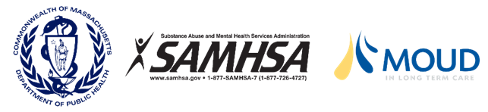
Self-Paced Learning Modules: The Care of Residents with Opioid & Stimulant Use Disorders in Long-Term Care Settings
On April 8, 2022, the Massachusetts Department of Public Health, in partnership with Abt Associates and Healthcentric Advisors, released a self-paced online course titled: The Care of Residents with Opioid & Stimulant Use Disorders in Long-Term Care Settings.
Based on The Care of Residents with Opioid & Stimulant Use Disorders in Long-Term Care Settings Toolkit, the course includes six, self-paced, online learning modules designed to help you provide high quality care to residents with opioid and/or stimulant use disorder.
Through this course, learners will expand their understanding of person-centered care principles, regulations, National Standards for Culturally and Linguistically Appropriate Services (CLAS) in health and health care, best practices related to care transitions, and partnering with Opioid Treatment and Office-Based Opioid/Addiction Treatment Programs.
Get Started
The Introduction, Modules 1 and 2 are now available. Subsequent modules will be released shortly. Each module can be completed at your own pace!
Nurses, Social Workers, and Administrators can earn 6.5 continuing education credits for completing the entire course (i.e., all six modules). All learners who complete all six modules will receive a Certificate of Completion.
Access the learning sessions using the following link: https://learningforquality.org/courses/the-care-of-residents-with-opioid-and-stimulant-use-disorder-in-long-term-care-settings/

For more information about this online course, please contact DPH’s partner, program director, Rosanna Bertrand at moud2@abtassoc.com.

